Creating JARs with JGrasp

**What is a JAR?** Have you ever wanted to show a friend a program you wrote in APCS? Chances are, they won’t be able to run it as easily as you. This is because you have the JDK, which allows you to convert *.java files to *.class files. Then the *.class file gets run by the main Java program.

**Why JGrasp?** One of JGrasp’s greatest strengths is its ease of use – while it doesn’t sport some of the features that IDEs like Eclipse or NetBeans do, it’s a highly flexible and powerful tool. This simplicity was brought over to making JARs too – there’s no need to navigate complex menus or options.

**Step 1**: Open your *.java file in JGrasp.

**Step 2**: Go to the upper menu and hit Project > New

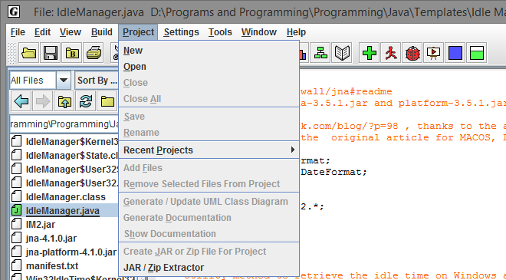

**Step 3:** Name your project and check “Create new directory.” It doesn’t matter what path you select at the bottom, as long as regular users (including you) have write privileges to the folder.

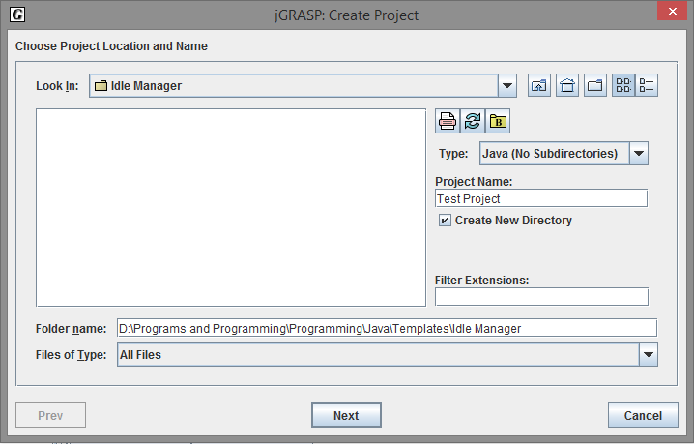

**Step 4:** Check “Add Files to Project Now” and hit “Create.”

**Step 5:** Select all *.java files (using the Shift key) required for your program and hit “Add.”

**Step 6:** You should see a dialog like the one below. Hit “Copy,” then “Done” on the dialog behind it.

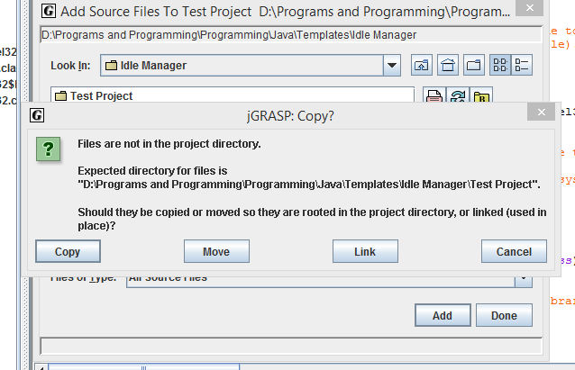

**Step 7:** At the bottom left corner of the JGrasp window, you should see a panel labeled “Open Projects.” Open each file and compile it (with the Green plus sign on the upper menu).

**Step 8:** You’re ready to create your JAR! Go to Project > Create JAR or ZIP File for Project. Select the “JAR File (Executable or Library)” option. The default checkboxes under “Project Files,” “Classes” and “Other Files,” should be fine.

**Step 9:** If you added non-native libraries to Java for the purposes of your program, you need to add them to the “Additional (non-project) Files” box. Otherwise, you can leave it empty.

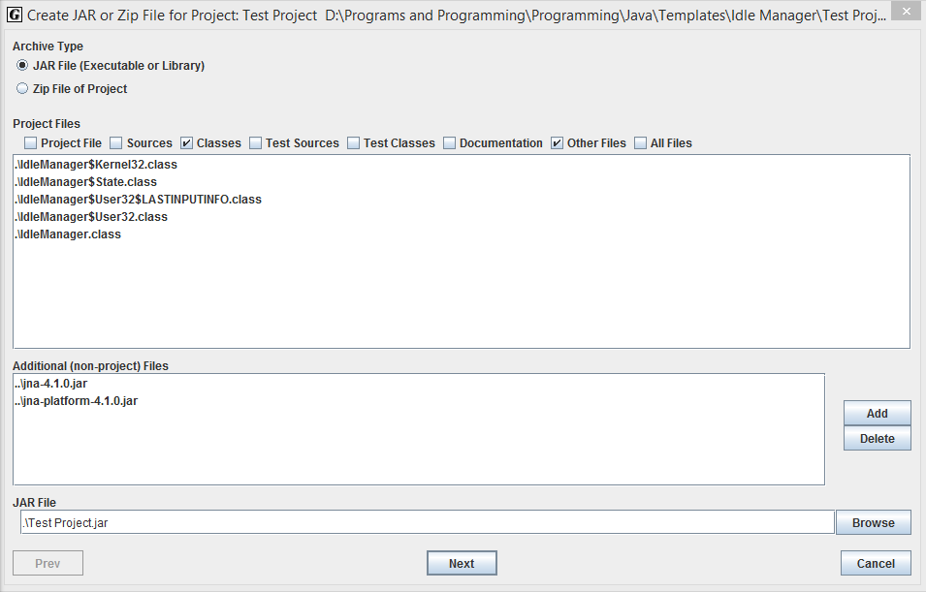

**Step 10:** Make sure the “Main Class” is the one that contains the main() method. The Manifest will create itself automatically. Go ahead and click “Create JAR!” The window will close, and you should see a line under “JGrasp Messages” that says ”Generated JAR file [path to your JAR].”

You’re done! You can run the Jar simply by double-clicking it.